Hello **{{Company.name}},**

Please find below a list of questions related to the billing process that will help us understand how you manage or would like to manage this through OfficeRnD. The more detailed information you can provide, the better.

If there are topics we need to discuss further, we’ll add a comment here or ask you to jump on a call (in those cases where there are various things to cover).

Kind regards,  
**{{Your name}}**

### **General settings**

1. Does your space use more than one currency to invoice customers? Which are those currencies?
2. What is the billing period you would charge your customers for?
   1. Does it start on a specific date from this month until the same date next month?
   2. Is it different for every customer (starts on the day they join your space)?
3. Would you use proration for those invoices where the customer didn’t use the service for the whole month?
4. Do you include 0-priced services (e.g. a membership with a 100% discount) in the customers’ invoices?
5. Do you issue invoices with a total amount 0?
6. Are your services taxable?
7. Is the tax rate included in or excluded from the service price?
8. What’s the tax rate % and name that we should use for your services?
9. Are there services that should use different tax rates (e.g. foods & beverages can have a lower tax rate in some countries than the office rentals)?
10. Are there company members that should pay for a service on their own (e.g. their company doesn’t cover the charges for parking memberships)?
11. Will you integrate OfficeRnD with Xero or Quickbooks Online?
12. What’s the invoice number template that your organization follows (unless you’d integrate with Xero or Quickbooks online)? For example, this is what you can have in OfficeRnD: INV{{year}}{{month}}{{number}}
13. Is the number template different for the credit notes you might have to issue?
14. Is there a payment gateway provider you’ll use that integrates with OfficeRnD (full list can be found [here](https://www.officernd.com/integrations/#payments))?
15. Should the customers’ invoices be auto-charged if you use any of our native integrations (this happens on the due date of the invoice, provided that the customer has added their payment details)?
16. If that payment provider supports credit card payments, would you apply a processing fee to those customers that use their CC to pay their invoices?   
    (OfficeRnD can apply a percentage (%) in addition to the amount due)  
    Please note that merchants are allowed to add surcharges whenever allowed by federal and state law. If they do, however, they must clearly notify customers with conspicuous signage or distinct terms in written agreements before charging customers.
17. Does your organization apply late fees to customers who delay their payments? (OfficeRnD can apply a percentage (%) after X number of days)

### **Generating invoices**

1. If you have more than one location and each location represents a different billing entity, should your invoices be generated in respect to where the usage was created, and not the default home location of the customer?
2. Are there services you invoice on specific dates or immediately upon purchase?
   1. For example, the fees for office rentals are invoiced on the 1st of every month, while booking fees are invoiced at the end of the month.
   2. Or for some groups of customers (e.g. drops-ins) you can create a flow that asks them to provide their payment details and be invoiced & charged up front when they purchase a service or book a resource. Please note that auto-charge is available as a setting in those cases when you’d use a payment gateway integration. The native integration should have the “Available on Member Sign Up and Public Calendar” option as well if you’d like to ask the customer to provide their details during the purchase flow - more details on what the different payment gateways support on our end can be found [here](https://help.officernd.com/hc/en-us/articles/360008754734-Payment-Gateway-Integrations).
3. In case the invoice template you’ll see below doesn’t meet your requirements and/or you’d like to customize it, please follow the steps outlined [here](https://docs.google.com/forms/d/e/1FAIpQLSfexLmoH20mWv0j36JGXDOIs4TGq27UNsNbqwSCMgGUTn5NBQ/viewform). Our technical support team will take it from there and will contact you in case they have questions or items to discuss with you.

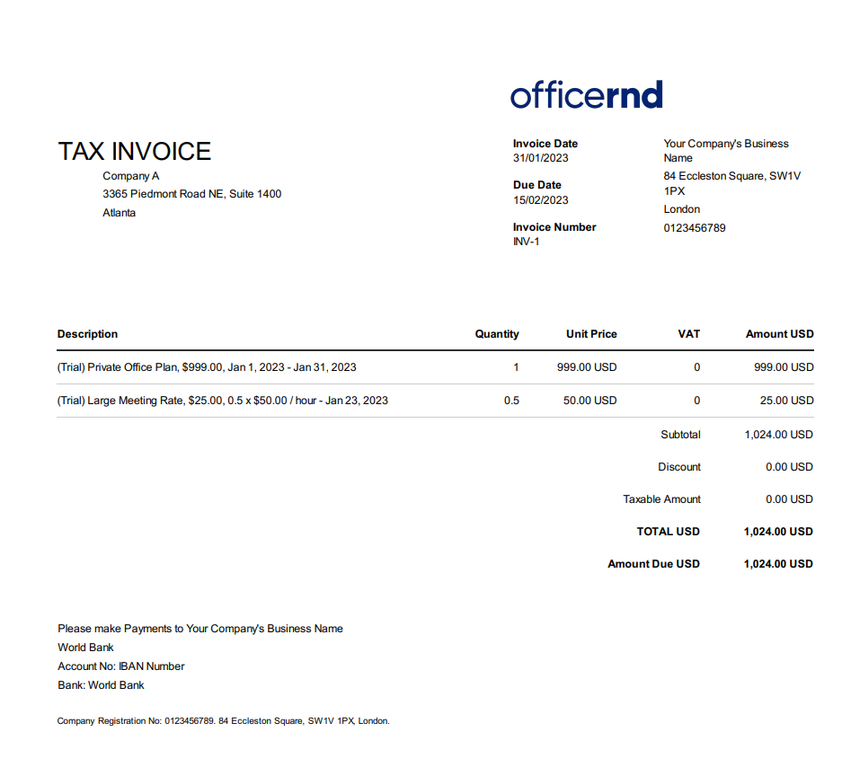

### **Email notifications regarding invoices & payments**

1. Who should receive the invoices - a company mailbox or the accountant of each company?
2. Do you send overdue reminders for the invoices that haven’t been paid yet?  
   (Up to 3 separate reminders, each X number of days after the due date)
   1. Reminder 1 X Days after Due Date
   2. Reminder 2 X Days after Due Date
   3. Reminder 3 X Days after Due Date
3. Do you wish to send payment receipts (available with a payment gateway integration only)?
4. Do you want to inform the customer via email if their payment has failed (available with a payment gateway integration only)?