***Welcome to our customizable template for creating a member guide for your OfficeRnD portal.***

***Before proceeding, please carefully review the following disclaimer:***

1. *This template is designed to support space operators or administrators in creating their unique member guide. Feel free to copy and customize this guide to meet your business requirements.*
2. *As the owner of the copy, you are responsible for the accuracy of information provided in the guide, including space details and contact information.*
3. *Additionally, you bear the responsibility of uploading and managing images for your space and member-facing tools. Please ensure that all images adhere to copyright laws, and you possess the required rights for their use and display****.***

Guide to

[Org Name]’s Members Portal

Welcome to the [Org Name]’s Members Portal. This is where you can connect with the members of the awesome community you are a part of. If at any point you have questions, don’t hesitate to email us directly at {email address} or contact your hosts.

Make sure to also keep track of the news feed on the **Dashboard** page to stay on top of everything that’s going on in our community and don’t hesitate to say your piece, we’d love to hear from you.

Here is more on what you can do from the portal:

1. **Sign in** to start using the portal.
2. **Manage** your profile to edit your details, sync social media, or view past bookings.
3. Explore your **community**, space and benefits.
4. **How To Guides** on getting started.
5. Verify your payment details, invoices and more under **Billing****.**
6. **Book** meeting rooms.
7. **Purchase** additional plans and services.
8. **Submit a Ticket** for issues or get in touch to provide feedback.
9. Communicate with your members via **Messages**.
10. **Events** offer a way to engage with members.

# 

# Sign In or Sign Up

Upon receipt of our welcome email, click on the "Sign in" link provided in the email and establish your password when prompted. Should you neglect to complete this process within 72 hours of receiving the email, kindly reach out to us at  {email address} to request a new invitation.

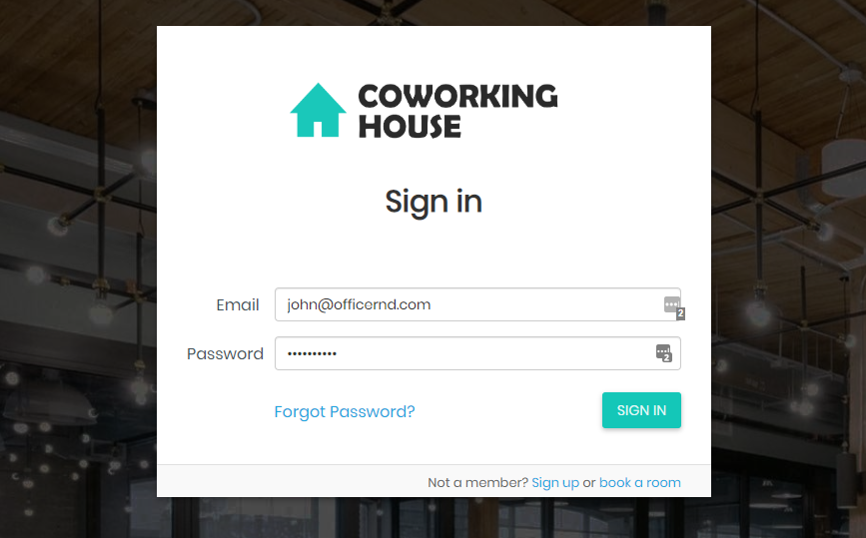

New to the space? No worries, click on Sign Up and choose a membership plan or simply fill up our signup form to get started.

Forgot your password? No worries, we’ve got you covered and will send you an email to help you reset your password.

# 

# 

# Manage your Profile

There are sections in the portal dedicated to different sides of your profile.

To access your profile, click on the icon in the top right corner and select ‘Profile’. Alternatively, you can click on the Personal Menu icon on the left hand side and ‘Profile’.

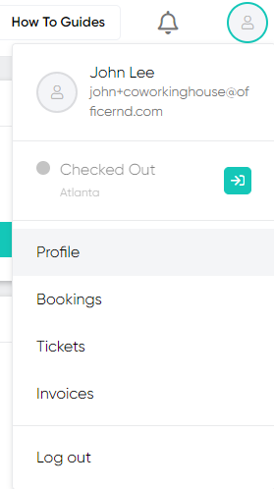 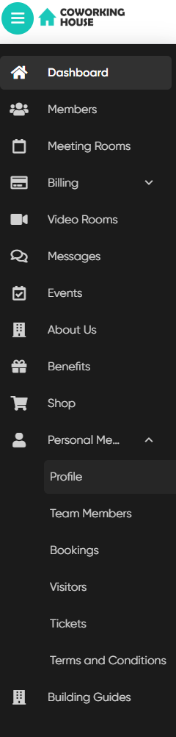

You can update your personal and company profiles, add skills, industries, and bio information under **Profile**. That’s where you can change your password or connect your profile to Twitter, LinkedIn, Facebook and/or Instagram.

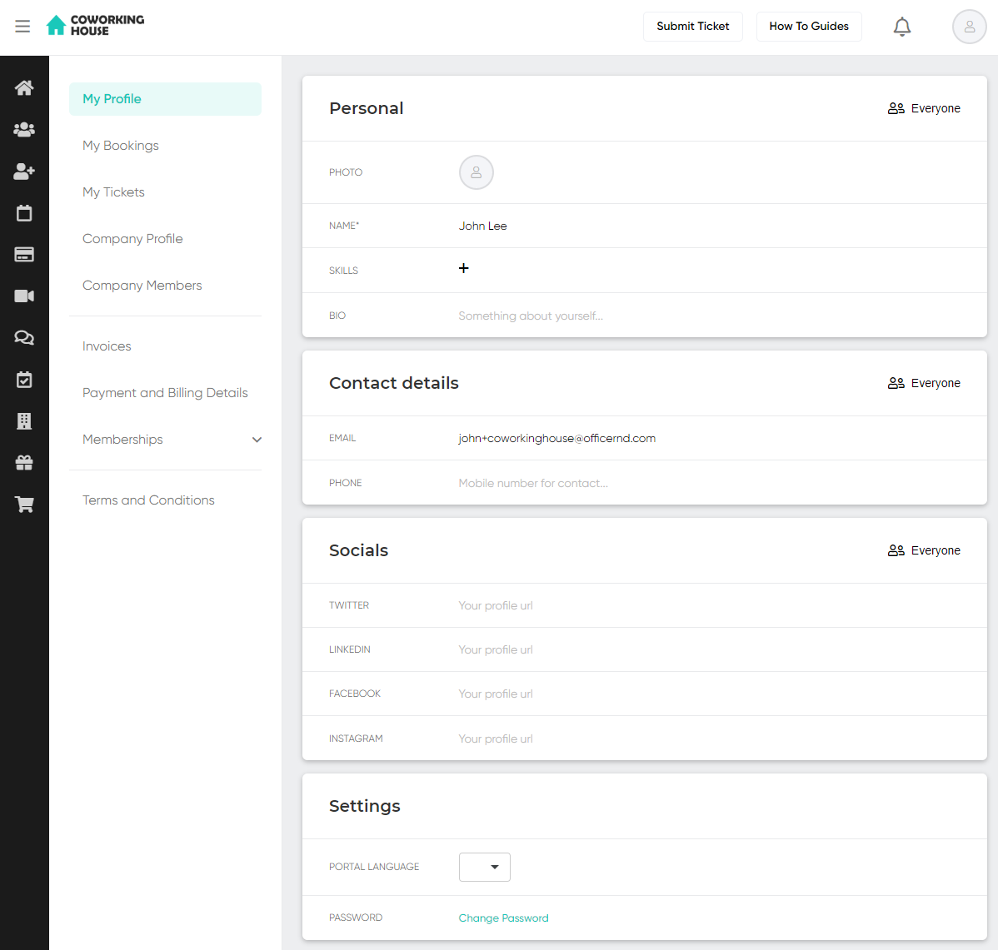

You can review your bookings and keep track of what’s coming or how many credits you have left under the **My Bookings** section.

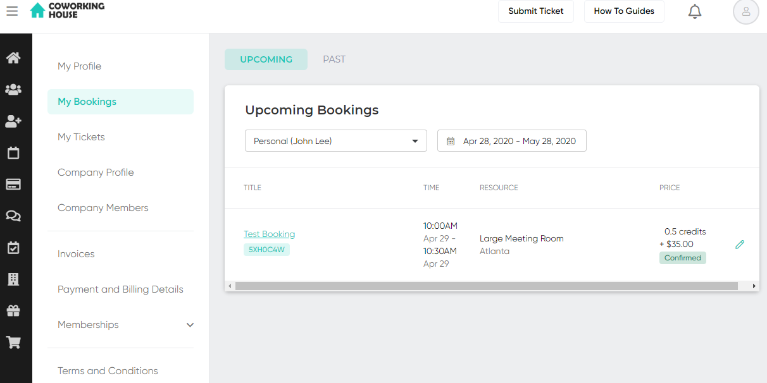

You can submit a ticket or see the status and history of tickets that have been submitted under the **Tickets.**

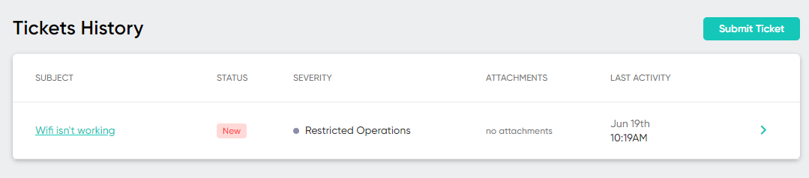

Usure of certain policies or want to check details of your membership, see the Terms & Conditions for a copy of the accepted documents.

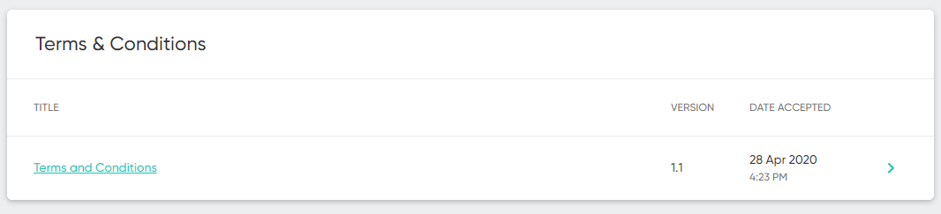

# Explore your Community

Under the **Community section** from the left hand menu you cansearch coworkers by skills, industries, names, companies. Being part of a coworking space is more than having flexible office terms. It is being part of an awesome community that can help you and your business grow faster, make friends and enjoy your time at work.

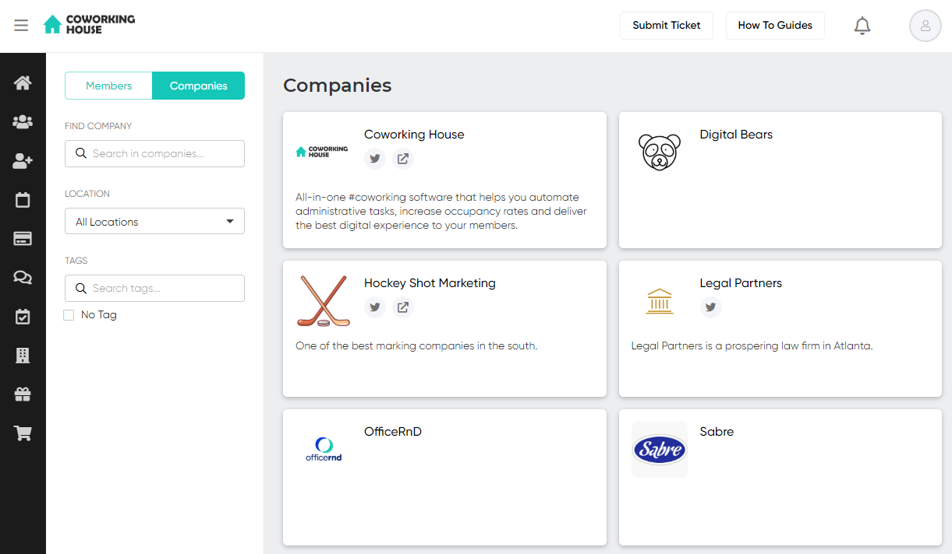

Explore companies, share information about your company and find members with similar skills and challenges. Be sure to connect and share experiences with fellow coworkers – they are only a click away in Twitter, LinkedIn and Slack.

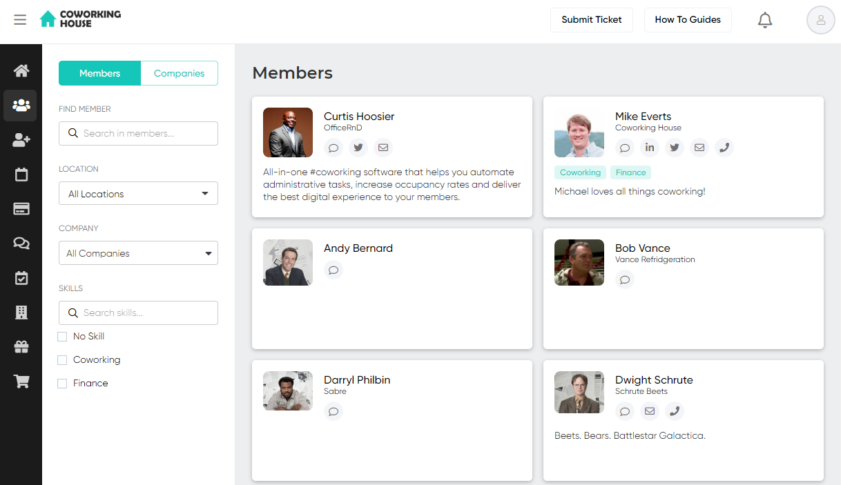

Navigate to the **Building Guide** and make sure to explore the coworking space - its house rules, Terms & Conditions and all how-to guides and any important information that will save you time and help turn the day-to-day errands to an effortless and quick task. 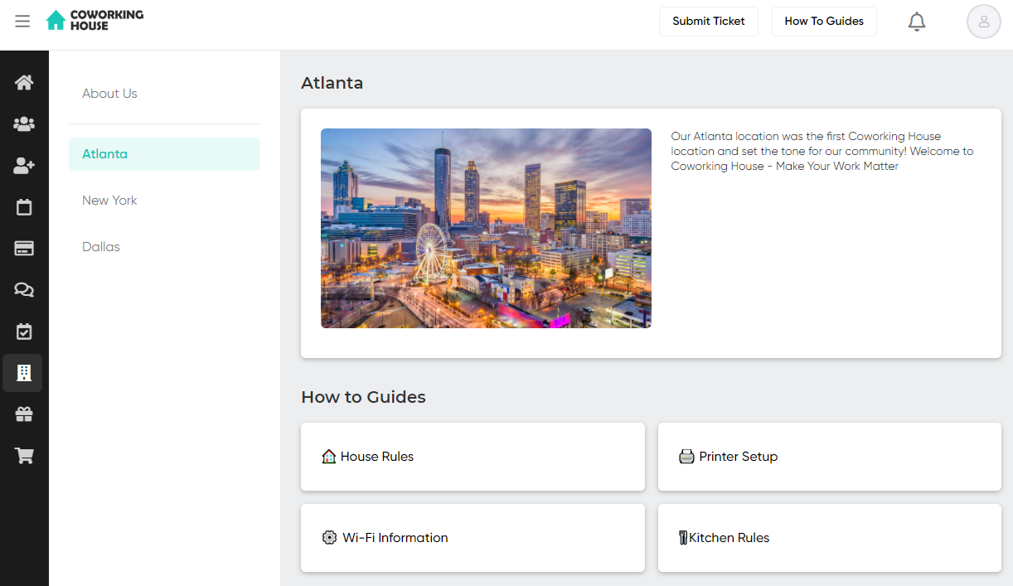

Want to know what benefits we offer? – go ahead and explore the **Benefits** section where you’ll find information about the perks and discounts that are available to all community members.

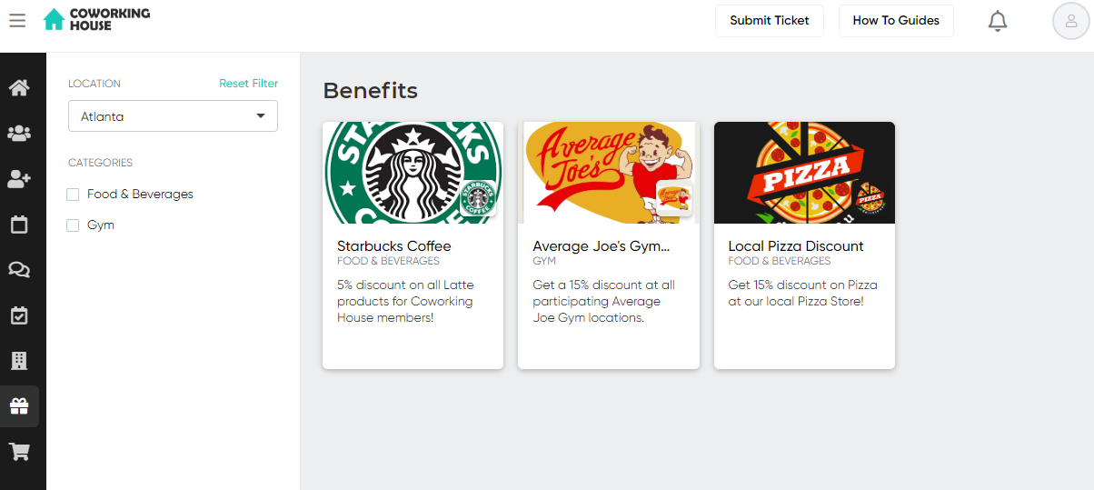

# 

# How To Guides

Anytime you have a question, click on the How To Guides at the top-right side of the toolbar and you’ll find all relevant how-to documents at your disposal.

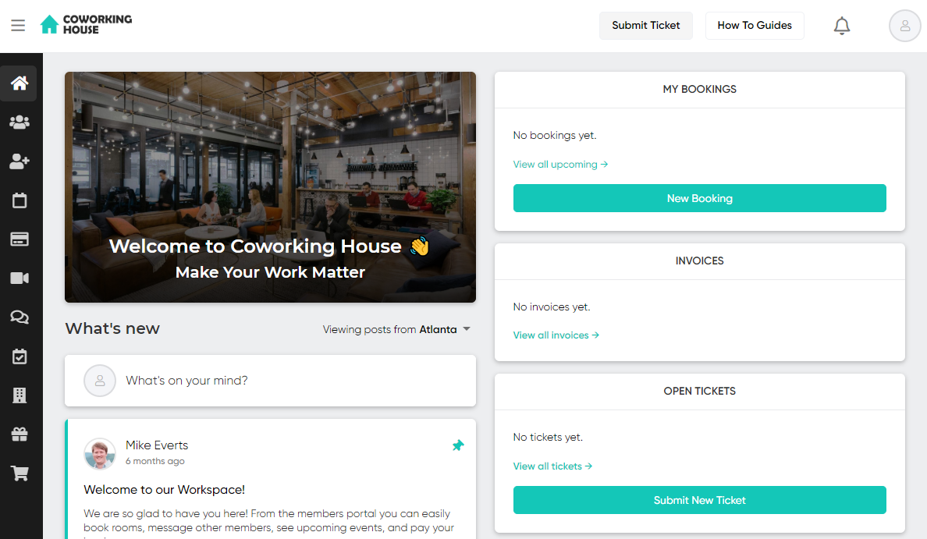

# 

# Billing

Under **Billing,** you can review your invoices, change your payment and billing details. You can **Pay Now** any outstanding invoices and download the PDF documents to send them to your accountants.

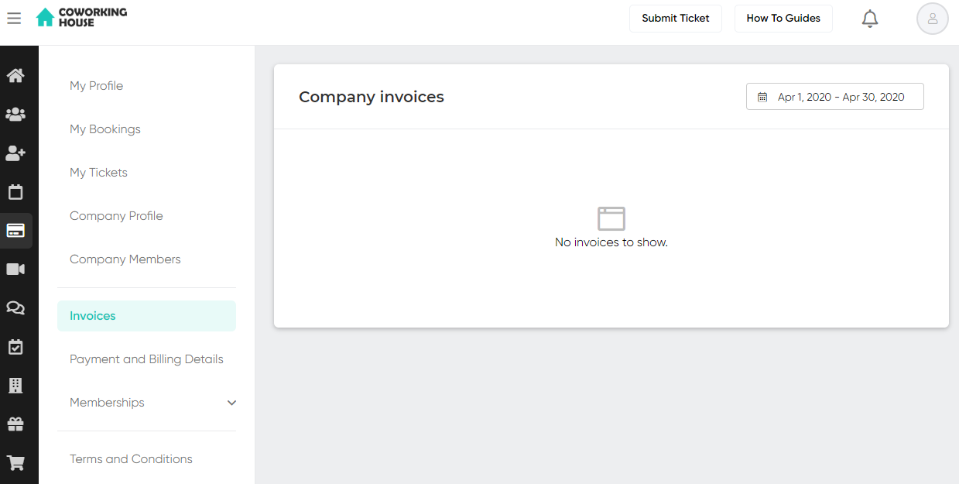

The **Memberships** section displays information about your day passes, memberships, and add-ons.

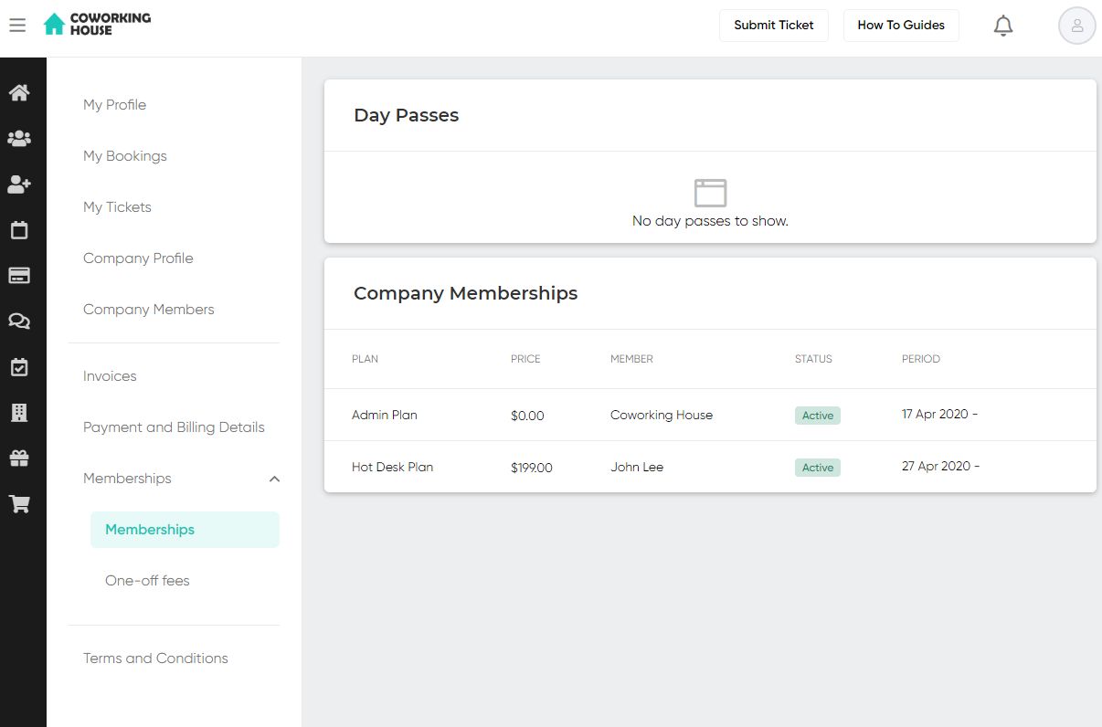

# Book Meeting Rooms

Booking a meeting/conference room is as easy as clicking on a free time slot on the **Meeting Rooms** calendar and confirming your preferred time slot. We will send you a confirmation email with a calendar invite attached. You can also see all your **Bookings** and **Remaining Credits** in the **Bookings** tab.  
  
Select **More Options** to see additional meeting room booking options, such as adjusting the meeting recurrence, adding guests, or adding a longer description to name a few. From this menu you can also select and add extras for the booking, which are added to the total cost of the booking under the Summary.

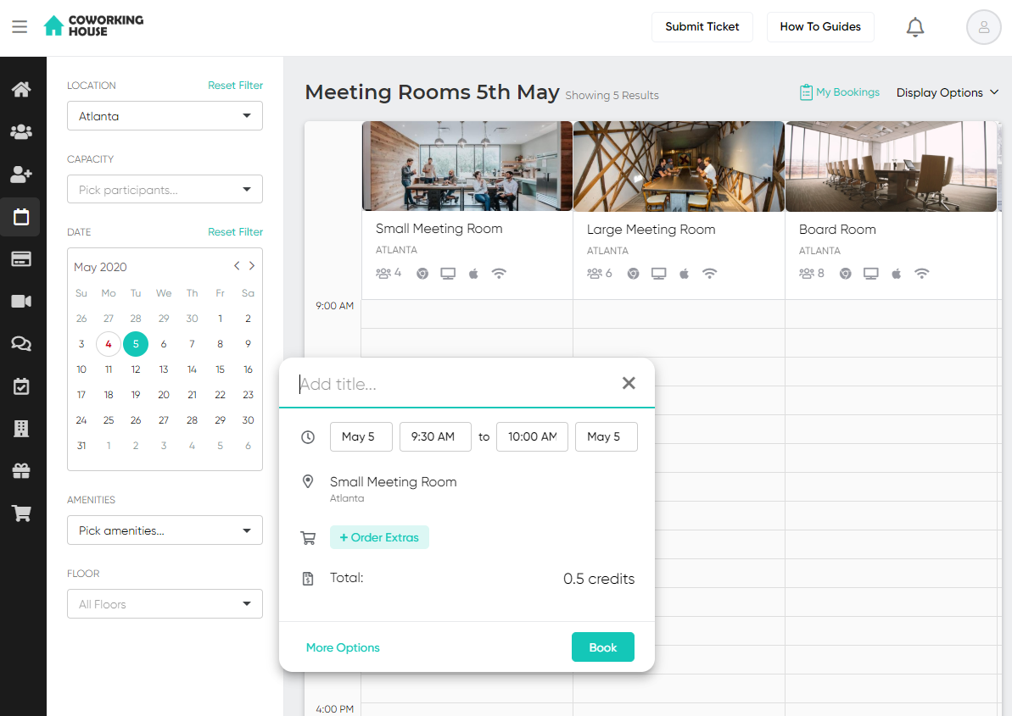  
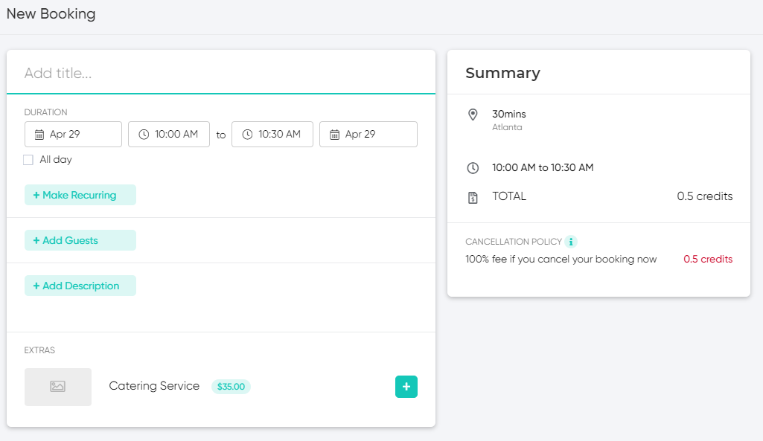

# Purchase Memberships & Services

Ready to expand or start using more services? Come talk to us or simply navigate to the **Shop** section. We’ve got all membership options and services available to you listed with additional information. Select the anything you’d like to add to your account and click **Buy Now**.

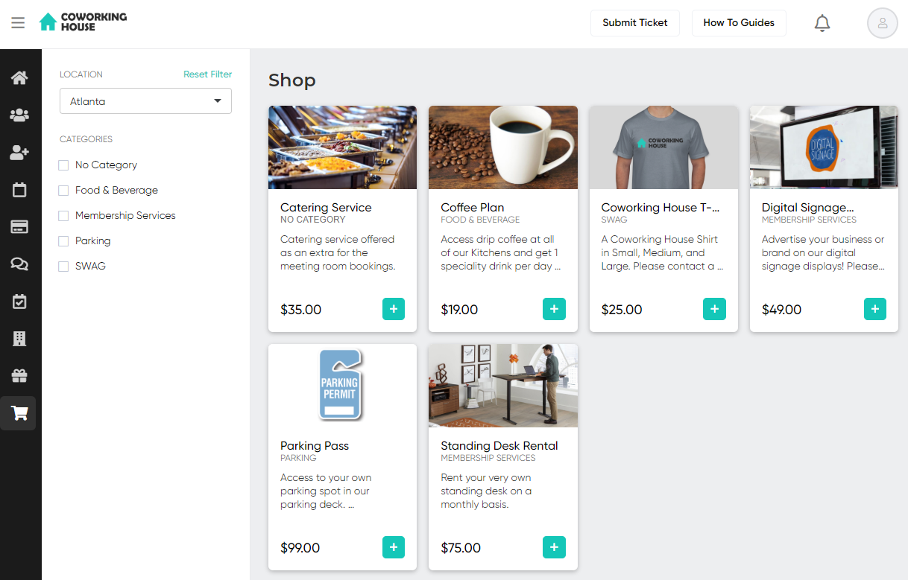

# 

# 

# 

# Tickets and Ticketing Functionality

Whether it’s to report issues with the WiFi or to provide quick feedback to the coworking space staff, the ticket functionality in the portal allows you to quickly see all your tickets as well as track their overall progress. You can easily submit a ticket using the **‘Submit Ticket**’ button located in the top right corner from anywhere in the member’s portal.  
  
  


They can also be easily submitted from the Tickets widget on the dashboard, and can also be submitted from your Profile page.

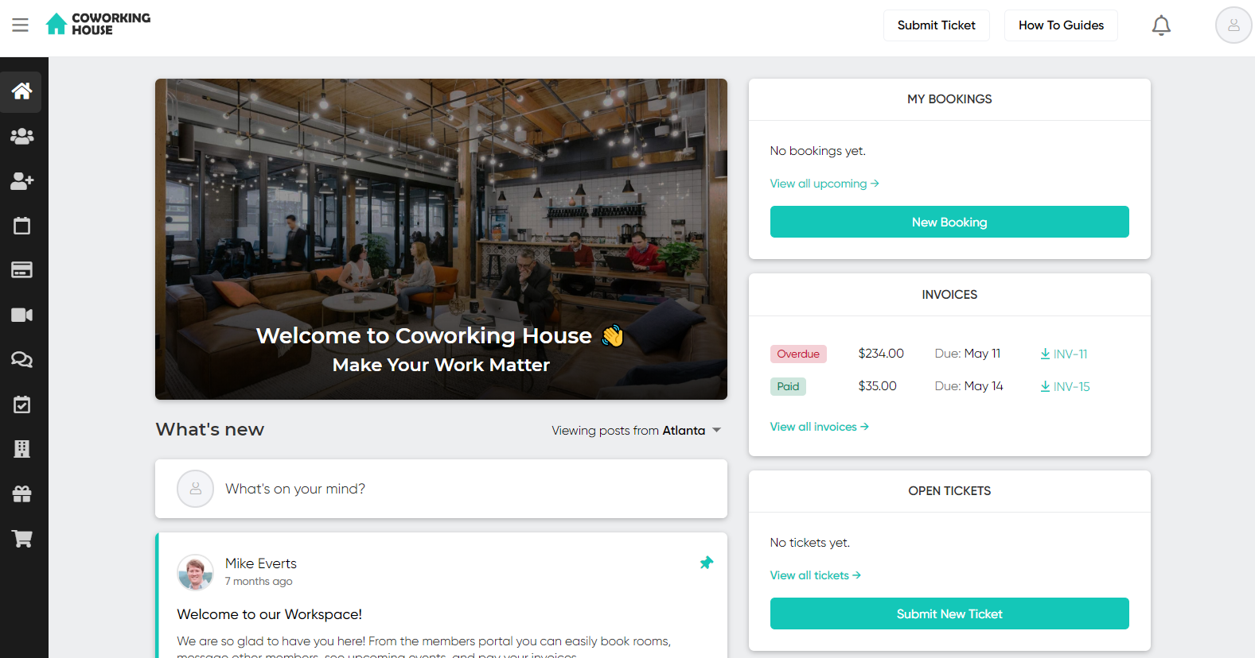

To see the status or history of submitted tickets, access the **My Tickets** section from either the Tickets widget on the home page and ‘View all tickets’ or go to your Profile and select My Tickets.

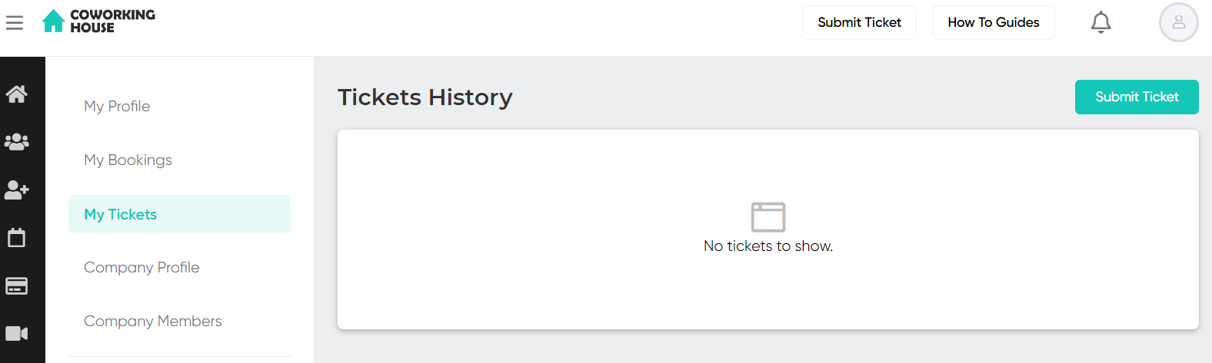

If you want to get in touch, use the **Submit Ticket** button available on the top right-side of the toolbar and shoot us a message. We’ll be in touch right away.

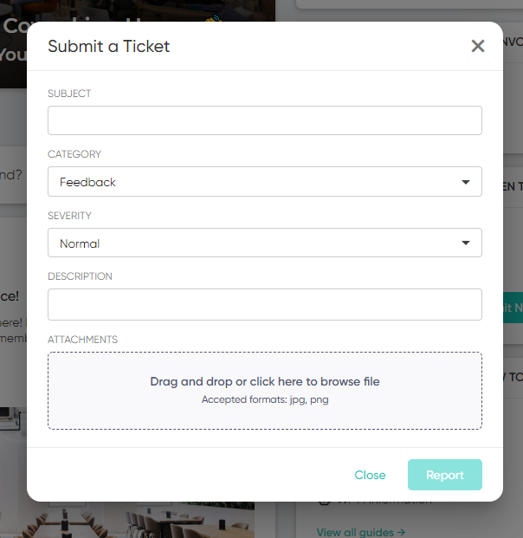

# 

# Messages

Want to chat and connect with other members? Check out the **Messages** tab to start a conversation by searching for the member. The messages can also be sent as an email.

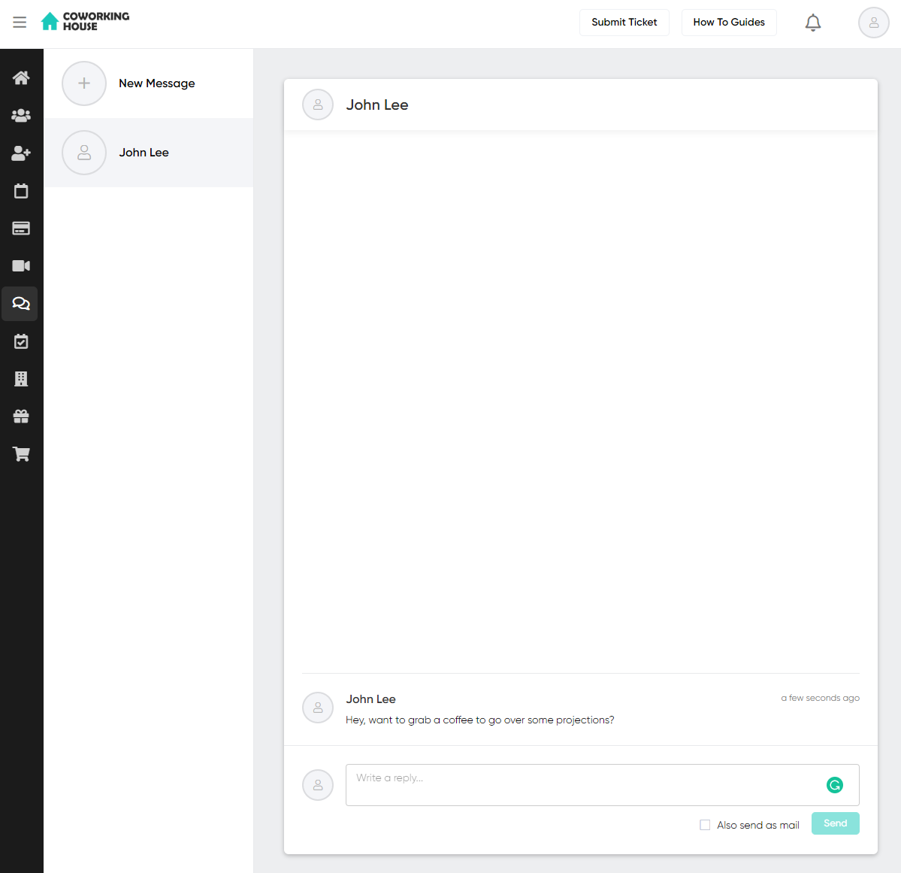

# 

# 

# Events

Head over to the Events tab to check out all of the happenings in and around the space.

